FINAL PRODUCT BREAKDOWN

# TEAM: [State Team number and Name here]

## Due Date:

Friday, March 27, 2020 at 11:59pm

Provide several pics of the completed system here:

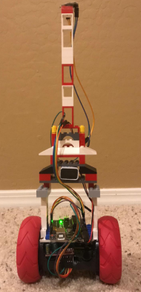

Figure 1: Final Product

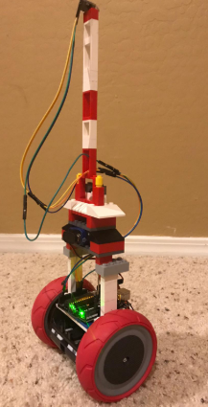

Figure 2: 3D View of Final Product

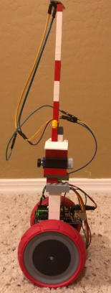

Figure 3: Side view of Final Product

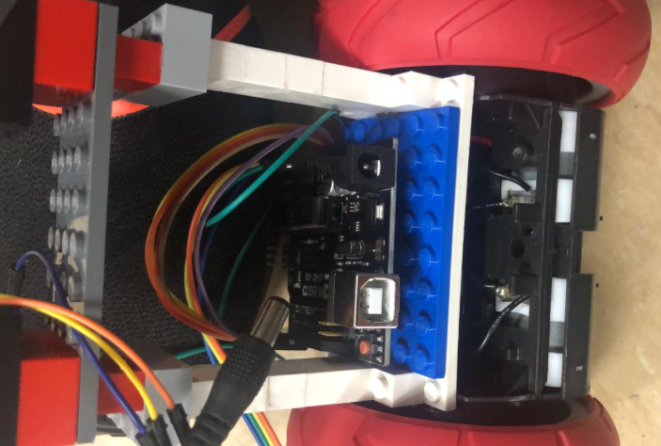

Figure 4: Central Part with the Arduino Controller

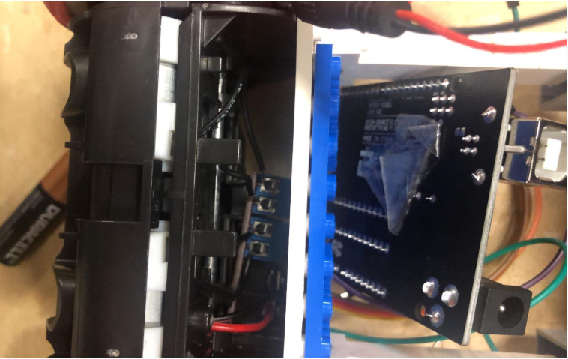

Figure 5: Base structure with motors

The following are the Action Items each person completed between Hardware Review 2 and the completion of the final product:

Team Member: Fahad Alostath

|  |  |  |
| --- | --- | --- |
| Action Item | **Date Completed** | **Result/Proof of Completion** |
| Written the Arduino Code | 03-03-2020 |  |
| Connected Batteries | 03-05-2020 |  |
| Developed Structure | 03-10-2020 |  |

Team Member: Naif Alfihan

|  |  |  |
| --- | --- | --- |
| Action Item | **Date Completed** | **Result/Proof of Completion** |
| Setup Connection for Accelerometer | 03-03-2020 |  |
| Setup Connection for Gyroscopes | 03-05-2020 |  |
| Developed the Body Structure | 03-10-2020 |  |

The following are the Action Items for each team member between the Final Product presentation and the Testing Proof:

|  |  |  |
| --- | --- | --- |
| Team Member | **Action Items** | **Date Due** |
| Fahad Alostath | 1. Arduino Code 2. Connected the Batteries 3. Motors Connections | 1. 03-03-2020 2. 03-05-2020 3. 03-10-2020 |
| Naif Alfihan | 1. Setup the Connection of Accelerometer 2. Setup the Connection of Gyroscopes 3. Developed the Body Structures | 1. 03-03-2020 2. 03-05-2020 3. 03-10-2020 |